**Using deep learning and sensory technologies for early detection and management of**

**learning disabilities and health conditions**

Akilbekov Alar, Sardarbekova Akaru, Yesbossyn Aiym

6B06102 — Software Engineering

MiII 3222: Research Methods and Tools

EndTerm assignment

Supervising Professor:Seitenov Altynbek

Kazakhstan Republic

Astana, 2023

**Introduction**

The topic of this study is “Using deep learning and sensory technologies for early detection and management of learning disabilities and health conditions”. Currently, the field of information technology is actively developing, we are introducing it into various processes, so another important and always relevant topic for humanity is medicine and healthcare [1]. In this study, we are studying the combination of information technology with medicine and how this synergy of spheres can be used to improve the convenience of humanity in different spheres, as well as to create and identify new, in-demand technologies.

The hypothesis of our research is that convenient and accessible technologies can be a contributing part to the overall improvement of people's health, maintaining health for patients and facilitating automated processes in medicine, helping healthcare professionals do their jobs.

Our topic promotes the search and identification for the use of computer science, engineering, and medicine to create and identify useful devices and technologies that already exist and improve them. We believe that if these devices are easy to use, easy to use, and adaptable to everyday life, then this can contribute to improvements in the fields of healthcare and automation. It turns out that the research is aimed at identifying and studying technologies that are at the intersection between the two fields of computer science and medicine

The context of our research is two areas: healthcare and medicine, but we are considering a fairly broad topic, and are not limited to a specific organization or place. In our case, a place can mean various healthcare institutions, and these include hospitals, medical centers, and clinics. If we take into account the people covered by the study, they include both medical workers and developers and engineers working on products of combined information and medical technologies. It turns out that we are also considering society, and this is treated as patients, that is, residents of the country, and workers in these two spheres.

First of all, with the help of the study we want to achieve an answer to our question about the totality of the fields of medicine and information technology, where the main factor is technology for use and consumption. There are also several goals that we want to achieve:

Explore:  
  
 - We want to find and define the most suitable and most convenient technologies that can contribute to the development of processes, improving the condition of people, which are widely available and easy to use.  
  
 - We are committed to exploring the possibilities that these technologies offer, how they can be used and applied

Clear description:  
  
 - We want to define technologies that address the issue of convenience and automation, describe and identify the relevant factors, as well as how they can benefit society, where they can be used, who they are suitable for and how difficult or easy they are to invent.

Understanding:  
  
 - We strive to understand which technologies are most useful and will have the greatest impact.

In general, our goal is that we want to find and describe those technologies from the fields of medicine and computer science that will be accessible to patients and help healthcare professionals do their jobs effectively.

The nature of the “Why” of our research question lies in our desire to solve pressing problems that arise in healthcare and harness the maximum potential of the field of information technology, which includes software, machine learning, Internet of things, neural connections, and computer science. In seeking to answer our research question, we are motivated by the fact that truly user-friendly technologies exist and can be applied in everyday life. Thus, “Why” is based on the desire to see the best results of the synergy of these areas, which will lead to quick tracking of the condition of patients or simplification of people’s lives both at work and during treatment, as well as quick diagnosis.

We have several potential connections that we would like to explore in this study. One of the most important is the impact on patient well-being.

-We want to determine exactly how the use of medical technologies can affect people’s condition.

-How technologies increase automation and efficiency, can they reduce the time workers and people wait for medical processes and services.

-We want to determine the correlation between accessibility and equality, that is, how accessible technologies must be in order for them to support or even lead to equality between people, whether technologies can be accessible to everyone, regardless of circumstances.

-Implementation. How interested and needed people are in these technologies, both consumers and manufacturers. What will motivate them to use these devices and technologies?

The social significance of our research lies in the fact that it has the potential to positively impact the lives of people from different spheres on a large scale. It turns out that by exploring the topic of accessible medical technologies, we can identify opportunities and solutions for solving social problems.

These include:

Health. The goal of the research is to make healthcare accessible by harnessing the potential of technology to simplify people's lives while improving their health.

Economic effect. Perhaps our research can help create more sustainable systems for treating and researching patients, and also reduce costs by constantly maintaining people's condition checks.

The result of the research can contribute to social progress in the field:

-Improved health indicators

-Speed of research

-Expanded access to medicine

Thus, our study has important implications from a social perspective. Its results can lead to improved healthcare delivery processes, operations, faster automation processes and improved health.

**Literature Review**

The combination of AI, machine learning, IoT, and sensor technologies is paving the way for significant advances in healthcare, promising better patient results, efficient disease management, and a comprehensive approach to medical treatment.

The rapid evolution of technology has greatly influenced healthcare and public health infrastructure. A significant emphasis has been placed on incorporating Soft Computing to enhance and optimize the healthcare domain, aiming to make it more adaptive and efficient [1].

Integration of Artificial Intelligence (AI) in healthcare diagnostics and treatment has seen significant advancements. Neural networks have shown promise in classifying cognitive test drawings, potentially revolutionizing cognitive examinations and making them suitable for telemedicine platforms [2].

Machine learning's potential in stroke medicine cannot be overstated. From precise diagnosis to personalized treatment selections, machine learning offers a paradigm shift in treatment outcomes [3].  
 By analyzing MRI images it is possible to draw conclusions about stroke [3].

Oncology, too, has witnessed the incorporation of AI, especially in hybrid imaging. Such applications primarily focus on automating tasks, improving disease characterization, and integrating diverse data sources for a comprehensive understanding of cancer [4].  
 Using ML and Based on several human analyses that would be time-consuming for doctors to analyze, it is possible to quickly predict cancers [4].

Specific ailments, like Parkinson's disease, have also been a focus. Automated methods are now being developed for early detection and severity prediction, aiding healthcare professionals in treatment planning [5].

Epilepsy monitoring has seen advancements with the combination of IoT and AI. Systems that predict and diagnose epileptic seizures promise effective monitoring and management of epilepsy [6].  
 If IoT tools with sensors that pick up brain impulses are available, it will be possible to use different AI methods to monitor and manage epilepsy [6].

Similarly, wearable systems using LSTM-based neural networks are being developed for blood glucose prediction, offering a revolutionary approach to diabetes management [7].  
 Using modern sensors on mobile phones, it is possible to measure blood sugar levels, monitor and manage diabetes more effectively, prevent complications related to irregular blood glucose levels and improve overall patient care and outcomes [7].

It is also possible to identify the stages of Parkinson's disease by analyzing the speed and pressure of the pen when drawing a spiral [10]. The authors introduced a new index, the Composite Index of Pen Speed and Pressure (CISP), which combines these two parameters to more accurately assess the severity of the disease. This method can be related to our study, as we also use the images obtained during the spiral drawing process to be analyzed using deep learning techniques.

Lastly, the potential of deep learning in detecting learning disabilities through handwriting analysis stands out. Not only does this offer early identification and intervention for children facing such disorders, but tools like "SensoGrip" also offer real-world applications for early dysgraphia detection [8][9]

Using machine learning techniques, it is possible to detect cognitive disorders from images of people's drawings and handwritten manuscripts [2]. It is also possible to analyze children's handwriting for learning disabilities detection [8]. A more convenient way is a pen (“SensoGrip”) with a sensor inside that detects dysgraphia in children [9].

It has been proved that it is possible to predict cognitive diseases from patients' drawings, and the sensor pen will be more convenient to use [2][9]. In machine learning, the more data, the better the prediction result. Both approaches have not been tested on real patients and collected relatively small amount of data for testing. With machine learning techniques, we don't need to search for key points manually, the algorithm can find them on its own. We can select groups of people, collect data and then test the device. In addition, the SensoGrip study was limited to dysgraphia only, and the authors point out that it is possible to test predictions of other problems [9].

Recent advances in the detection of learning disabilities have focused on dysgraphia, a disorder that affects the written expression of symbols and words. One study in this area proposed a nuanced methodology for the automated diagnosis of dysgraphia through handwriting analysis [11]. The researchers used a specific template to capture handwriting data, which facilitated the extraction of essential features required for machine learning analysis. A mixture of known and novel features were extracted from the handwriting samples and used to train machine learning models to recognize handwriting affected by dysgraphia.

**Problem:**

Our research addresses a problem in the medical field, namely the early detection and treatment of learning disabilities and health conditions, with a particular focus on dysgraphia. This disease and similar diseases have a great impact on a person’s quality of life. Definitely, in order to avoid the development of the disease, one of the best solutions is intervention and early diagnosis. Thus, we use modern information technologies that will help ensure prevention and create methods for detecting the disease, which will subsequently help us manage the method of treatment and examinations.

**Research Questions:**

- How well can computer models perform at recognizing diseases using photographs of people's drawings?

- If we set up a model to recognize drawings, could we detect dysgraphia?

- What computer models are best suited for disease recognition purposes?

- How can this model be used in the medical field?

- Using what indicators can we determine the reliability of the model?

**Methodology**

**Objective**

The main goal of our research is to harness the power of deep learning and sensory technologies for the early detection of learning disabilities, with a particular focus on dysgraphia. Our methodology is strategically built around a selected dataset that serves as the foundation for our analytic approaches. Dysgraphia negatively impacts both academic performance and overall well-being, so early detection is critical for timely intervention. Having collected a handwriting dataset in this way, we can use machine learning algorithms to predict dysgraphia from handwriting. Through careful analysis of these handwriting samples, we aim to identify nuances and facilitate technological advances that will make a significant contribution to the early identification and support of people with dysgraphia.

**Mixed Methodology Application**

For our research, we use quantitative analysis, which means the presence of statistical calculations and working with digital data. Thus, we obtain the results in numerical form. But we do not exclude qualitative data. In this regard, an example could be expert opinions or subjective interpretations. It turns out that by mixing quantitative and qualitative approaches we strive to complete our research. In this way we get a more complete picture and in addition to the numerical factors, we have the opportunity to obtain human aspects regarding the research topic.

**Dataset**

The dataset used was selected and aimed at detecting dysgraphia through handwriting analysis. The dataset includes handwriting samples that capture patterns and variations that help distinguish individuals with dysgraphia from those without. It consists mainly of handwriting samples collected according to special templates to ensure consistency and relevance in the data collection process. Each sample in the dataset contains a certain amount of information comprising various features related to handwriting, including pressure, speed and stroke length. This data set forms the basis for subsequent work with machine learning and model testing.

In our study we used a specialised dataset pioneered by Drotár & Dobeš [11], which represents a unique point of view for the study of dysgraphia in Slovak orthography. Data for the sample were collected from Wacom tablets, which collected x and y values of pen position on the tablet, movement in the air, time, pressure, speed, tilt, azimuth. The sample data also included children's data: age, gender, and main hand. It includes writing the letter "l", the syllable "le", the simple word "leto", the pseudoword "lamoken", the compound word "hračkárstvo" and the sentence "V lete bude teplo a sucho". The writing task was completed by 120 pupils, of whom 63 had normally developing handwriting and the remaining 57 had dysgraphia.

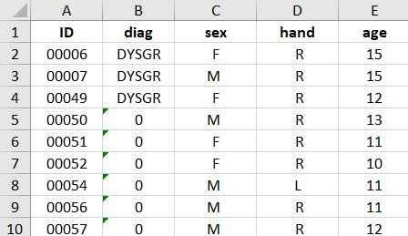

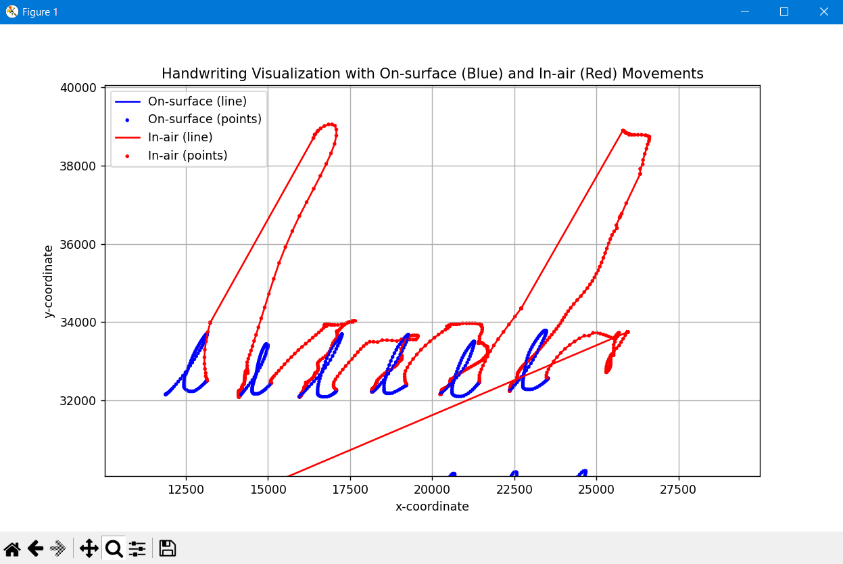

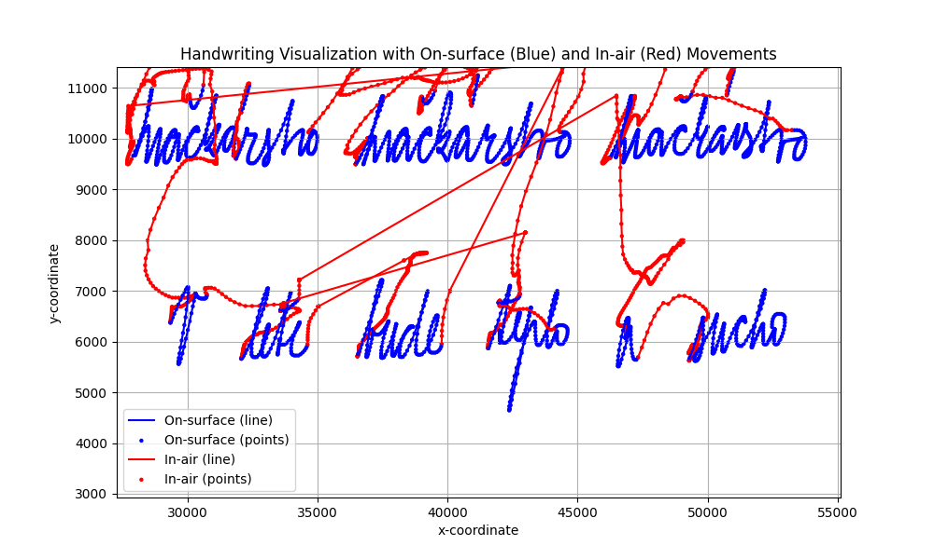

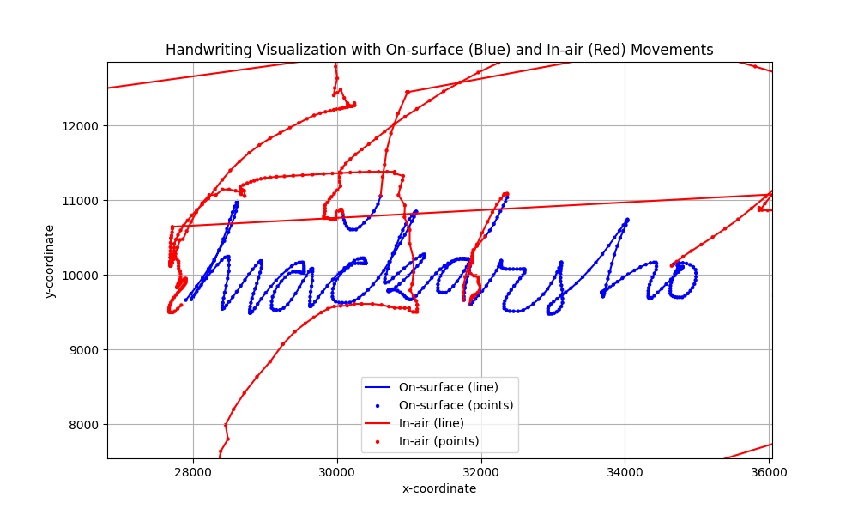

**Data Preprocessing**

A mandatory step is data preprocessing, which is carefully designed to optimize the data set itself, which will subsequently be needed for model training. In the initial stages of our study, careful attention is paid to refining and optimizing the dataset, a crucial step to ensure the reliability and accuracy of the subsequent analysis. The handwriting samples that form the basis of our study undergo a number of preprocessing steps. These include normalization to standardize the data, segmentation to extract meaningful features, and thorough cleaning to remove noise and irrelevant information. Each of these steps is carried out, yielding a data set that is both robust and reflects the inherent patterns and characteristics needed to identify dysgraphia.

Within our data preprocessing system, an important transformation was the conversion of pen handwriting data into a structured image format. This transformation consisted of converting dynamic handwriting traces, initially captured by the precise tools of the digitizing tablet, into static images. By synthesizing these traces into images, we transfer the fluidity of handwriting into a fixed medium that not only preserves the basic characteristics of the script, but also allows for greater flexibility in data manipulation and analysis. This representation of handwriting as an image allows the application of sophisticated image processing techniques and opens the way to the use of advanced pattern recognition algorithms, which is very important for the subsequent stages of model training and dysgraphia detection.

To avoid overtraining our model, we used artificial augmentation techniques like random cropping and image rotations.

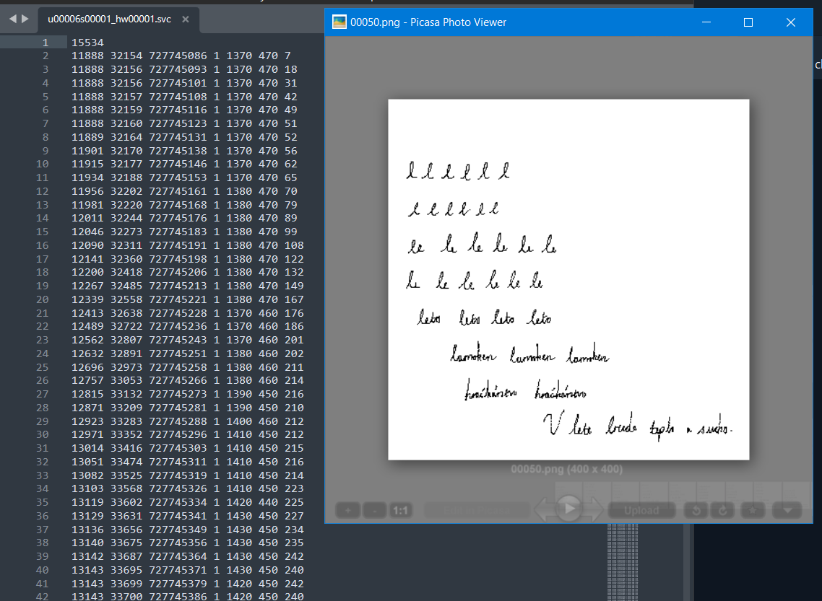  
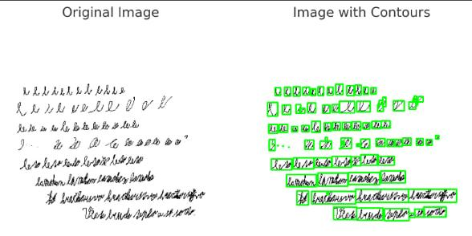

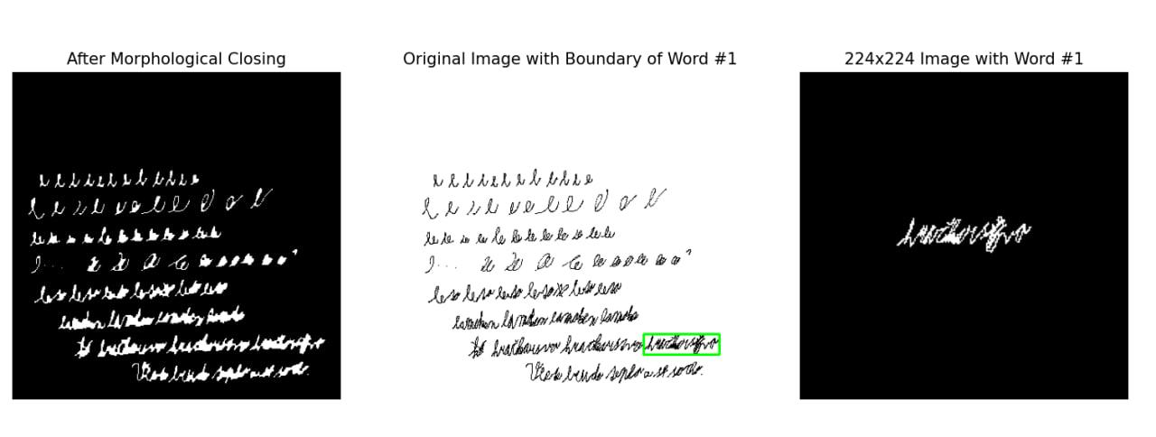

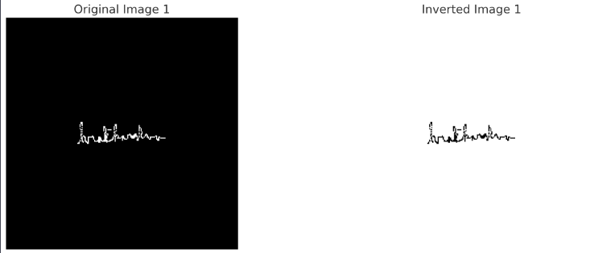

**Model Architecture and Training**

Our study took a multi-faceted approach to model architecture and training. Primarily, a convolutional neural network (CNN), the VGG16 model, was used, specifically tuned for our binary classification challenge - distinguishing handwriting samples from individuals with and without dysgraphia. The model, which was pre-trained on a large dataset, significantly helps to distinguish between these two categories.

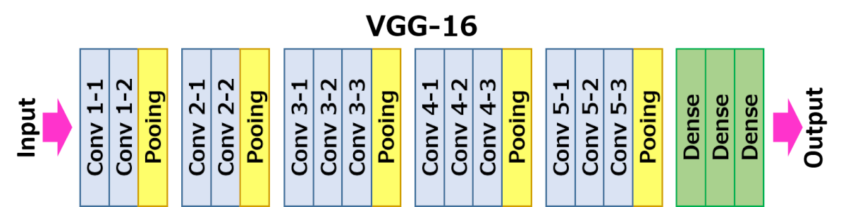

In the foundational study that informed our dataset selection, a comparison of various machine learning algorithms was conducted to evaluate their effectiveness in detecting dysgraphia [11]. The models included Support Vector Machines (SVM), Random Forest (RF), WkNN-FS and AdaBoost. The results indicated a commendable performance across the models, with the AdaBoost classifier emerging as the most accurate, achieving a near 79.5% success rate in classifying handwriting samples. It was particularly noted that the 'hračkárstvo' task contributed significantly to the predictive accuracy of the AdaBoost classifier. This empirical evidence underscores the robustness of ensemble classifiers, like AdaBoost, in handling complex real-world classification tasks. Inspired by these findings, our study seeks to build upon this established groundwork, aiming to enhance the precision and reliability of dysgraphia detection through the innovative application of convolutional neural networks.

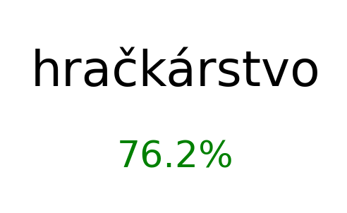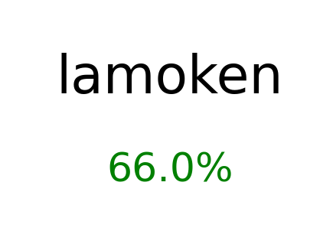

The total dataset was divided into training, validation and test sample for fairness in calculating the results. To ensure the model's robust performance and adaptability, a strategic application of 5-fold cross-validation was adopted. This strategy underscores our commitment to improving the reliability and accuracy of the model in detecting dysgraphia, and is perfectly aligned with our goal of fostering a model that is not only powerful in predictive analysis, but also resilient to different handwriting characteristics.

In general, this helps us distinguish objects among our data in two ways: a manuscript with potential impairments, namely dysgraphia, and one without it. At this stage, the model has good performance and fits our dataset. Of course, we check the reliability of its operation and for this we use a certain strategy, it helps us in the accuracy of the results, the strategy is called 5-fold cross-validation. At the moment it is the best suited for our needs and for our classification task.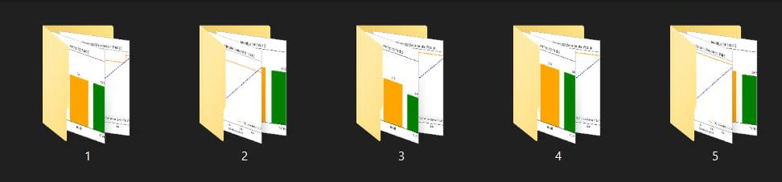

**Evaluation**

We take a multifaceted approach, in turn we use accuracy metrics as well as F1 score. This applies to all subsequent performance evaluations of our models. We consider this important point necessary because it provides the following definition of strength, and in addition to this we can also point out points and areas where, on the contrary, more effort can be applied and the model can be improved.

Precision = TruePositives / (TruePositives + FalsePositives)

Recall = TruePositives / (TruePositives + FalseNegatives)

F-Score = 2TruePositives / (2TruePositives + FalsePositives + FalseNegatives)

The best fold was fifth with an area under the ROC curve of 0.94. We were able to achieve an F-Score accuracy of 79.17% on a test sample that did not participate in model training. These results reflect a fair evaluation of our trained model.

**Validation**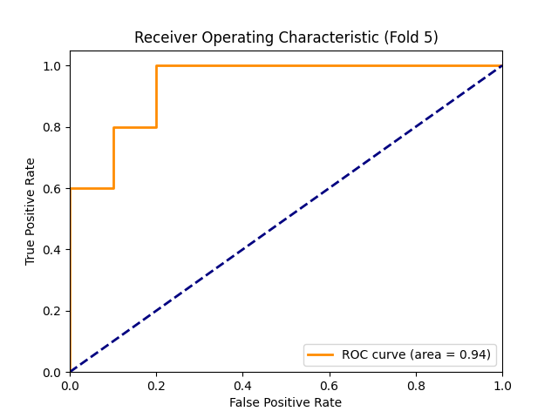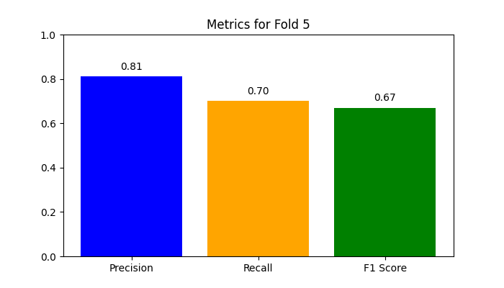

**Test  
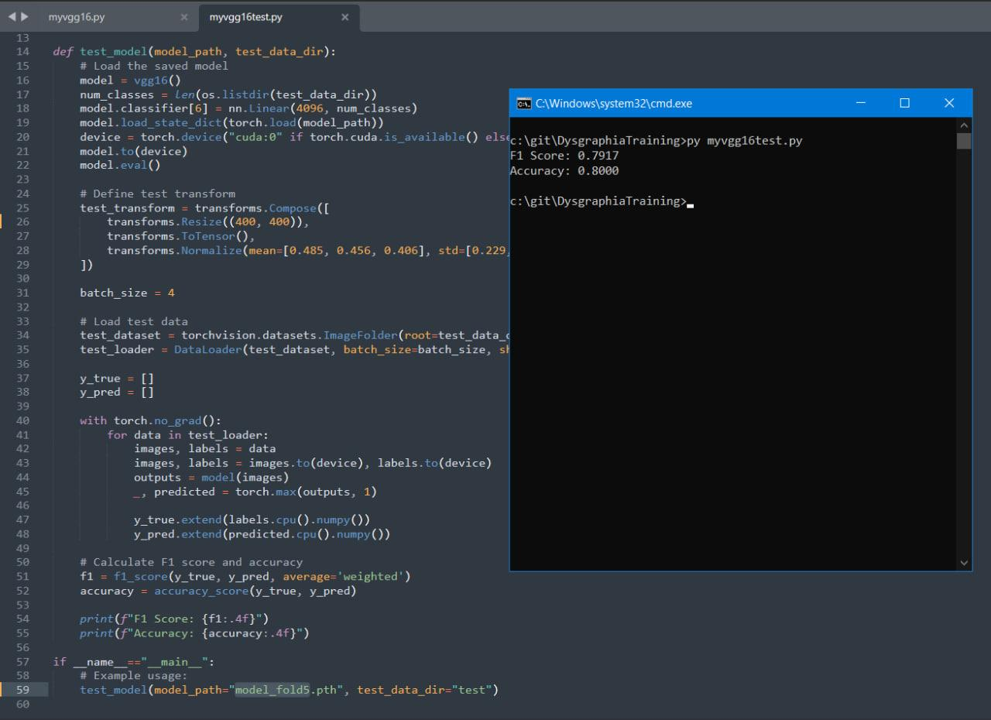**

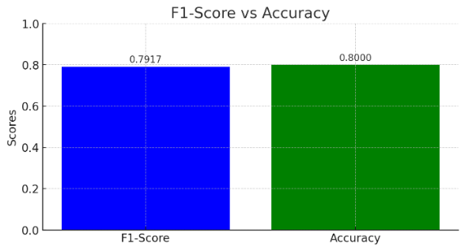

We also trained the model to classify words rather than sentences.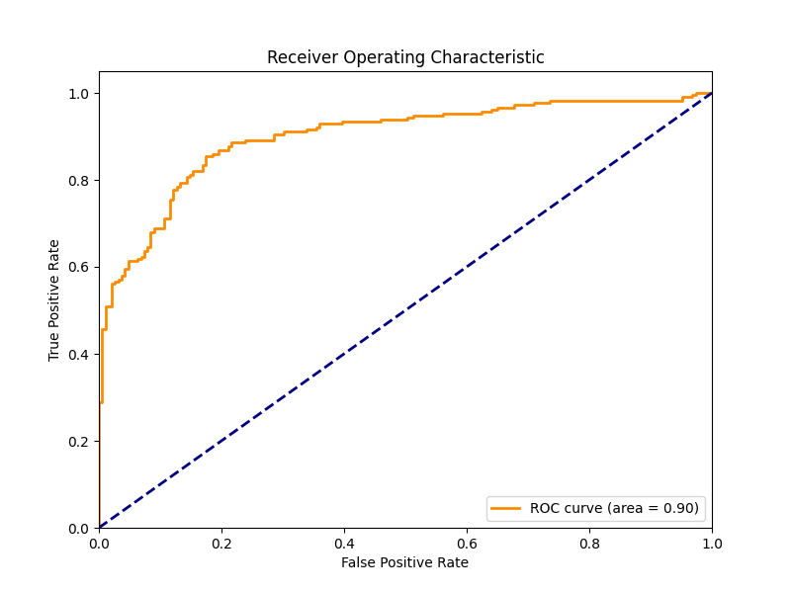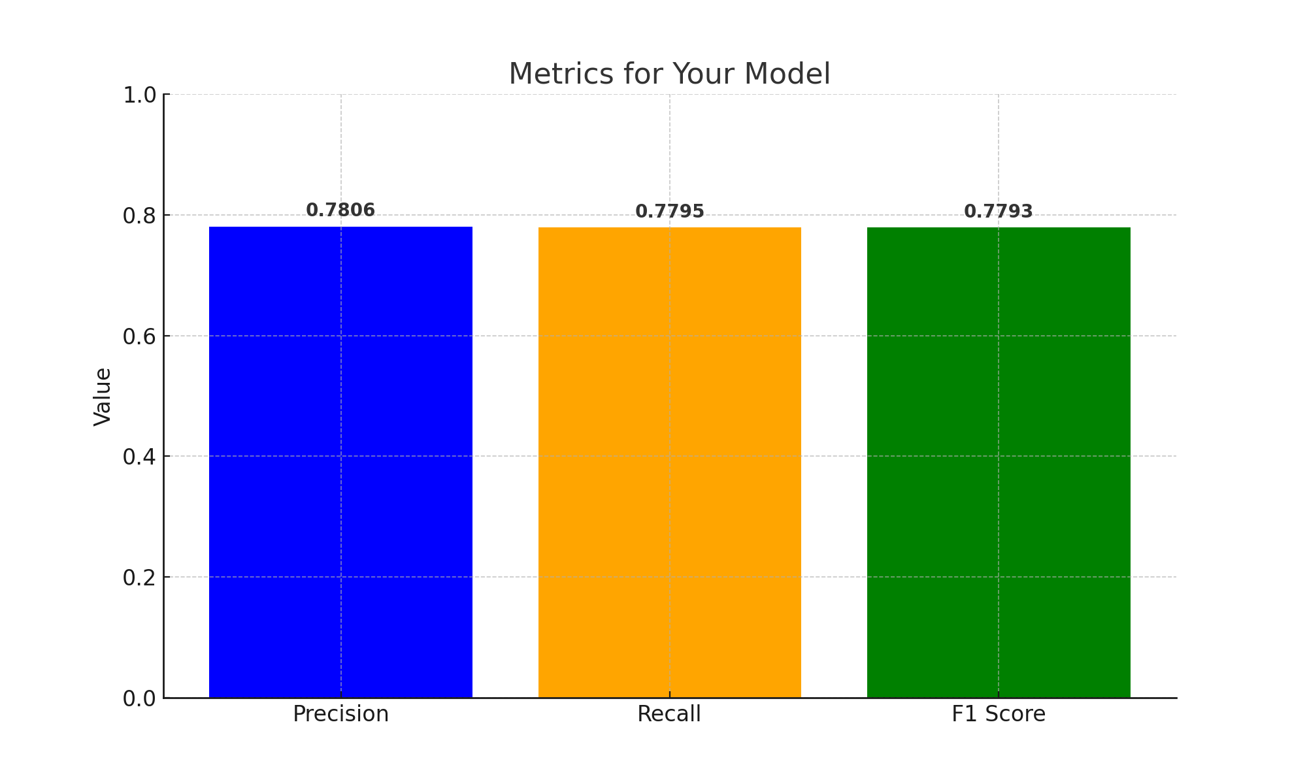

**Implementation**

In order to fully implement our methodology, we use the PyTorch framework. We chose it because it has an extensive set of functions, which in turn help us implement many aspects and stages of our research, making them more efficient, such as data processing or model evaluation.

**Advantages of Image-Based Analysis**

The conversion of handwriting samples into image data marks a paradigm shift in the approach to diagnosing dysgraphia. This methodology frees research from the limitations of specialized equipment such as Wacom tablets, which, while accurate, are often expensive and not available everywhere. By exploiting the widespread distribution of photographs, we open the door to a more democratic and scalable form of analysis. Image-based handwriting recognition harnesses the power of computer vision and machine learning to identify dysgraphia patterns from simple snapshots of writing. This not only expands the possibilities for large-scale screening, but also significantly reduces the economic and logistical barriers associated with traditional handwriting analysis methods.

**Sampling Methods**

**Stratified Random Sampling**

Our goal is to develop and validate AI and sensor-based tools and methods to detect and manage various diseases, in particular cognitive impairment and dysgraphia, and for this task we decided to choose stratified sampling as the most appropriate sampling method.

We can divide our general population into different strata (e.g. people with dysgraphia, people with cognitive impairment, healthy people, etc.). We can then randomly select samples from each stratum to train and test our models.

This method ensures that each subgroup is represented in your sample, which is especially important if you are investigating different diseases or conditions.

Also, given that we can test the predictions of other problems, we can consider expanding the study to other diseases or conditions using the same sampling method.

**Implementation and Tools**

**Selecting a programming language and libraries**

For our work, we chose the Python programming language, and for the completeness of the work, we relied on machine learning libraries, which are usually used for research in the field of data analysis and machine learning. In this regard, Python provides us with a whole set of tools, as well as libraries: NumPy, pandas, scikit-learn, and PyTorch. All this together helps us process data and also develop models and evaluate their performance.

**Data preparation**

The data preparation phase involved converting handwriting samples obtained with Wacom graphics tablets into images for analysis. This conversion is a step away from the use of specialized equipment in favor of more accessible tools for data collection. We used image preprocessing techniques to standardize and augment the handwriting images, ensuring the reliability and generalisability of the model. The PyTorch transformation module was used to augment, simulate different handwriting conditions and improve the trainability of the model, allowing resizing, arbitrary rotation and normalization of images.

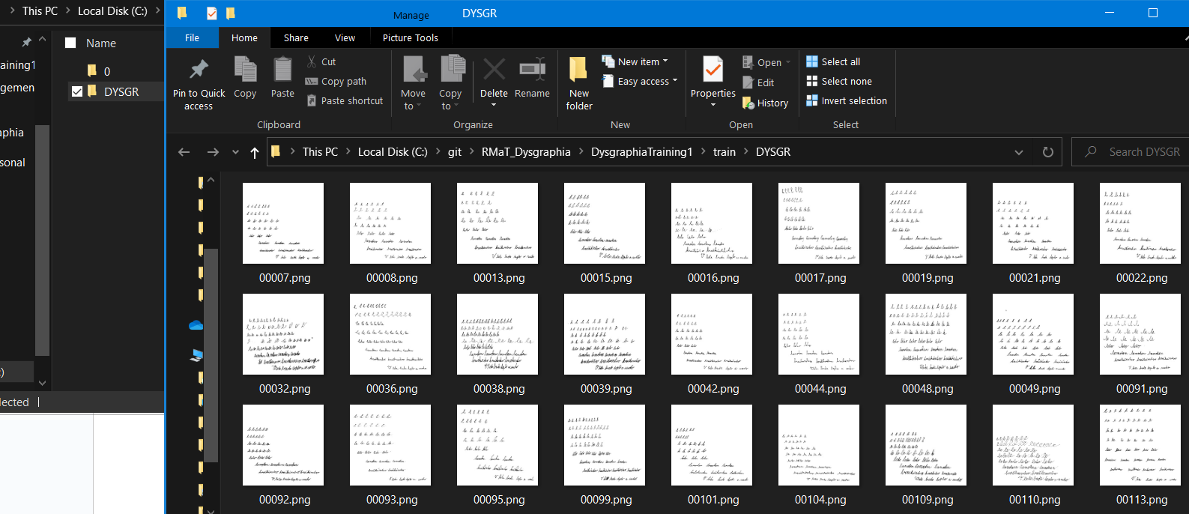

**Model architecture**

In this study, we applied a convolutional neural network (CNN), specifically the VGG16 model, which was specifically tuned for the binary classification task, to classify manuscript samples into those with and without dysgraphia. In addition, we compared this model with the original article in which we used Support Vector Machines, Random Forest and AdaBoost to evaluate their performance in the dysgraphia detection task.

**Model training**

We applied a 5-fold cross-validation strategy to improve the reliability and accuracy of this model. This helps us ensure that our model generalizes well to the data and is capable of handling different characteristics of the manuscript. Training parameters such as learning rate, batch size and number of epochs were tuned to optimize the learning process. A stochastic gradient descent (SGD) optimiser with momentum was used to accelerate convergence, and the learning process was accelerated by using CUDA-enabled GPU to significantly reduce computation time.

All experiments were implemented in the Python language. Training and evaluation were performed on a machine equipped with a CPU Intel(R) Core(TM) i5-11300H processor running at 3.10 GHz (3110 MHz) with four cores and an Nvidia RTX 3060 Laptop GPU.

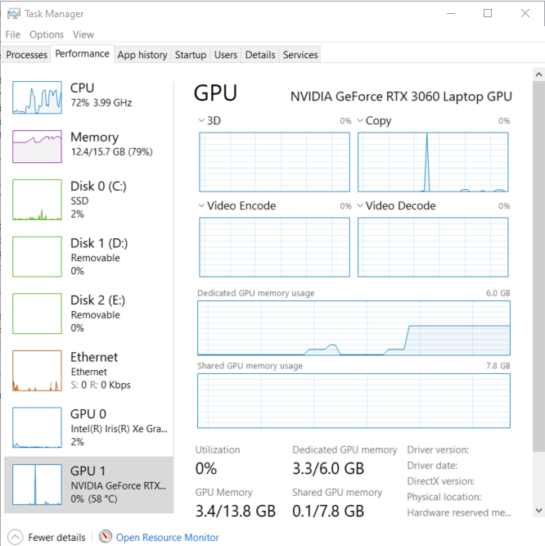

**Model evaluation**

To evaluate the performance of a model, you need to use certain metrics. In our case, we used several metrics: accuracy and F1-score. This helps us in assessing the strength of the model and also identifying areas of improvement. During the training process, the best result was achieved in the fifth iteration with an area under the ROC curve of 0.94 and an F1-score of 79.17%.

**Tools and Resources**

To implement the methodology, we used the PyTorch framework. Our choice is based on the fact that it has great functionality. These capabilities help us in data processing and model evaluation. The benefits of image-based analysis are worth highlighting.

Thus, we used the PyTorch framework to implement the methodology and process the data. We also considered the choice of stratified random sampling as a data sampling method and its significance.

**Source code structure**

The project source code was organized to ensure a smooth workflow. It included separate scripts and modules for data population, model instantiation, training routines, validation loops and metrics visualization. The codebase was designed with modularity in mind, allowing for easy experimentation and extensibility to handle additional datasets or model configurations.

The code can be found on the GitHub page: <https://github.com/Alar-q/DysgraphiaRMAT>

**Results**

The results of our research project demonstrated the benefits of applying deep learning to analyze image-based handwriting data. By translating handwriting samples into image form, we used computer vision techniques to detect dysgraphic patterns. The developed models recognised these patterns, which could be a significant step forward in the early detection of dysgraphia. The results were almost similar in terms of accuracy, but our model is self-training in contrast to the strict classification algorithms. We have O(N) training and O(1) classification complexity. They have O(1) training and O(N) classification. The use of images also makes the diagnostic process more accessible, removing the dependence on specialized equipment and making it scalable for wider application.

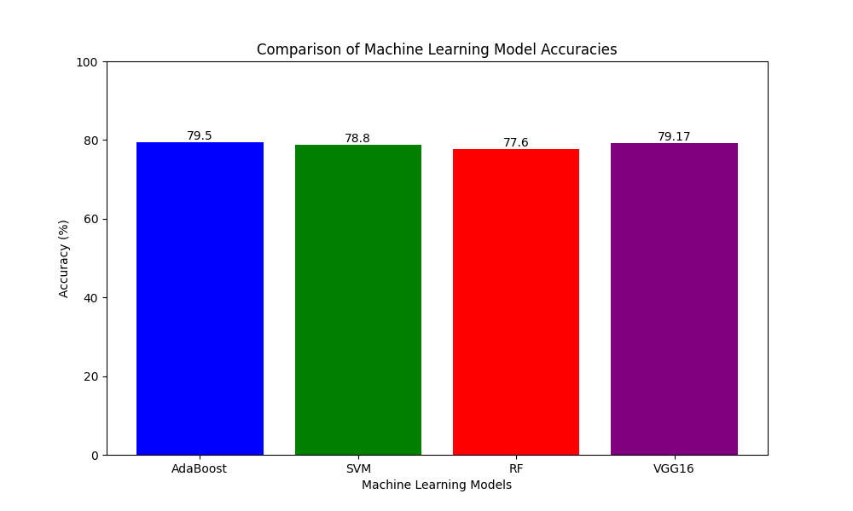

**Discussion**

Our research has made advances in the use of deep learning to analyse handwriting images for the detection of dysgraphia. This has been achieved by converting handwriting samples into digital images and applying computer vision techniques to detect dysgraphic patterns. Notably, our model is self-learning, providing a more dynamic and efficient approach than traditional strict classification algorithms. This aspect of our study demonstrates a more flexible and scalable approach to diagnosis, suggesting potential applications beyond dysgraphia.

Moreover, as the results of the studies studied in the course of our work show, similar classification methods can be used to detect Parkinson's disease based on the analysis of patients' drawings. This demonstrates the versatility of our methodology to not only detect dysgraphia but also diagnose other neurological diseases such as Parkinson's disease. Thus, our approach is well aligned with the broader scope of deep learning and sensory technologies for the early detection and treatment of various diseases and learning disabilities.

Thus, this study effectively bridges the gap between the potential of artificial intelligence in healthcare and its practical applications, particularly for the early detection of diseases such as dysgraphia and Parkinson's disease. The findings highlight the synergy between informatics and medicine, demonstrating the transformative impact of integrating technology into healthcare to improve patient outcomes.

Despite the results achieved, our study recognises certain limitations. The main issue is the sample size, which, although diverse, still limits the ability to train machine learning algorithms to their optimal performance. This limitation may be the reason for the scatter in the results obtained by different machine learning models. In addition, there is inconsistency in the features by which dysgraphia can be distinguished, which may be due to the small sample size and differences in the occurrence of dysgraphia across age groups.

In conclusion, our study has not only provided new data and techniques for recognising dysgraphia, but has also opened up prospects for future research. There is potential to study these techniques in different orthographies and at different developmental stages, and to extend their application to other learning disabilities and health conditions. Integrating our results with current neuroscientific research on dysgraphia and related disorders may lead to further improvements in prediction methods, allowing for a deeper understanding of the development of these conditions.

**References**

1. Haroon, M., Tripathi, M. M., Ahmad, T., & Afsaruddin. (2022). Improving the healthcare and public health critical infrastructure by soft computing: An overview. Pervasive Healthcare: A Compendium of Critical Factors for Success, 59-71.
2. Howard, C. W. (2023). Neural networks for cognitive testing: Cognitive test drawing classification. Intelligence-Based Medicine, 8, 100104.
3. Daidone, M., Ferrantelli, S., & Tuttolomondo, A. (2024). Machine learning applications in stroke medicine: advancements, challenges, and future prospectives. Neural Regeneration Research, 19(4), 769-773.
4. Sollini, M., Bartoli, F., Marciano, A., Zanca, R., Slart, R. H., & Erba, P. A. (2020). Artificial intelligence and hybrid imaging: the best match for personalized medicine in oncology. European journal of hybrid imaging, 4(1), 1-22.
5. Ayaz, Z., Naz, S., Khan, N. H., Razzak, I., & Imran, M. (2023). Automated methods for diagnosis of Parkinson’s disease and predicting severity level. Neural Computing and Applications, 35(20), 14499-14534.
6. Yedurkar, D. P., Metkar, S., Al-Turjman, F., Yardi, N., & Stephan, T. (2023). An IoT Based Novel Hybrid Seizure Detection Approach for Epileptic Monitoring. IEEE Transactions on Industrial Informatics.
7. Tena, F., Garnica, O., Davila, J. L., & Hidalgo, J. I. (2023). An LSTM-based Neural Network Wearable System for Blood Glucose Prediction in People with Diabetes. IEEE Journal of Biomedical and Health Informatics.
8. Vilasini, V., Rekha, B. B., Sandeep, V., & Venkatesh, V. C. (2022, August). Deep Learning Techniques to Detect Learning Disabilities Among children using Handwriting. In 2022 Third International Conference on Intelligent Computing Instrumentation and Control Technologies (ICICICT) (pp. 1710-1717). IEEE.
9. Bublin, M., Werner, F., Kerschbaumer, A., Korak, G., Geyer, S., Rettinger, L., & Schoenthaler, E. (2022). Automated dysgraphia detection by deep learning with SensoGrip. arXiv preprint arXiv:2210.07659.
10. Zham, P., Kumar, D. K., Dabnichki, P., Poosapadi Arjunan, S., & Raghav, S. (2017). Distinguishing different stages of Parkinson’s disease using composite index of speed and pen-pressure of sketching a spiral. Frontiers in neurology, 435.
11. Drotár, P., & Dobeš, M. (2020). Dysgraphia detection through machine learning. Scientific reports, 10(1), 21541.
12. Kunhoth, J., Al Maadeed, S., Saleh, M., & Akbari, Y. (2023). CNN feature and classifier fusion on novel transformed image dataset for dysgraphia diagnosis in children. Expert Systems with Applications, 120740